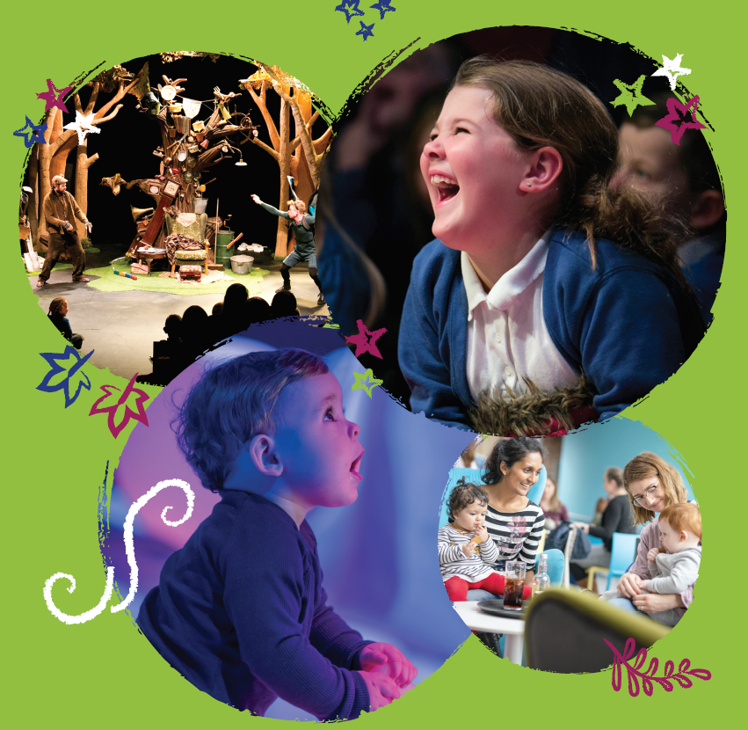

PROGRAMME ASSISTANT RECRUITMENT PACK

SPRING 2021

WELCOME

Thank you for your interest in the role of Programme Assistant at Theatre Hullabaloo.

Theatre Hullabaloo is one of the UK’s leading children’s arts organisations. We make, produce, promote and programme world-class theatre for young audiences. In December 2017, we opened The Hullabaloo, a purpose-designed venue for children and families in Darlington, which is where we are based.

Theatre Hullabaloo is a small team fired with passion and commitment to impact the lives of our local audiences and also to contribute to national and international conversations about the role of the arts and creativity in children’s lives. We are a friendly and inclusive organisation who work hard to support and meet the varying needs of people who work with us to ensure we employ the best people to do the job and that they represent the communities we serve. We are now looking for a Programme Assistant to support the delivery of our ambitions.

The Programme Assistant is a new role at Theatre Hullabaloo designed to support our day-to-day programming activities and delivery of the artistic and engagement programme at The Hullabaloo.

This application pack gives you an overview of Theatre Hullabaloo, the Job Description and Person Specification and details of how you can apply. Please note that the deadline for applications is 21st June 2021 at 12 noon .

If you would like to discuss the role prior to application, please email info@theatrehullabaloo.org.uk so that a phone call with Miranda Thain, CEO/Artistic Producer or Sarah Churlish, Programme Manager, can be arranged.

We look forward to receiving your application.

Miranda Thain
Chief Executive/Artistic Producer

ABOUT THEATRE HULLABALOO
Theatre Hullabaloo believes that creativity should be part of everyone’s childhood. We are a pioneering organisation that makes, tours and promotes theatre for children and young people because we believe that they are the most important audience of all. Established as Cleveland Independent Theatre Company, a general regional touring theatre company in 1979, the organisation became a specialist young people’s company in 1994 (CTC Theatre) and was then reimagined as Theatre Hullabaloo in 2009.

Theatre Hullabaloo is a National Portfolio Organisation (NPO) of Arts Council England, a registered charity and one of the leading specialist children’s theatre organisations in the UK. We make and commission new work for audiences from birth to 16 years which tours regionally, nationally and internationally to a mixture of theatres, venues, schools, nurseries and community settings. We also deliver a busy artist and sector development programme, believing that our audiences deserve work made by the most brilliant of artists and we work with a range of partners and stakeholders to produce research into the value of creativity in the lives of children which impacts on national policy in this area.

‘If this was weekly, I would bring my child every week!’

- Audience member (Lullabub)
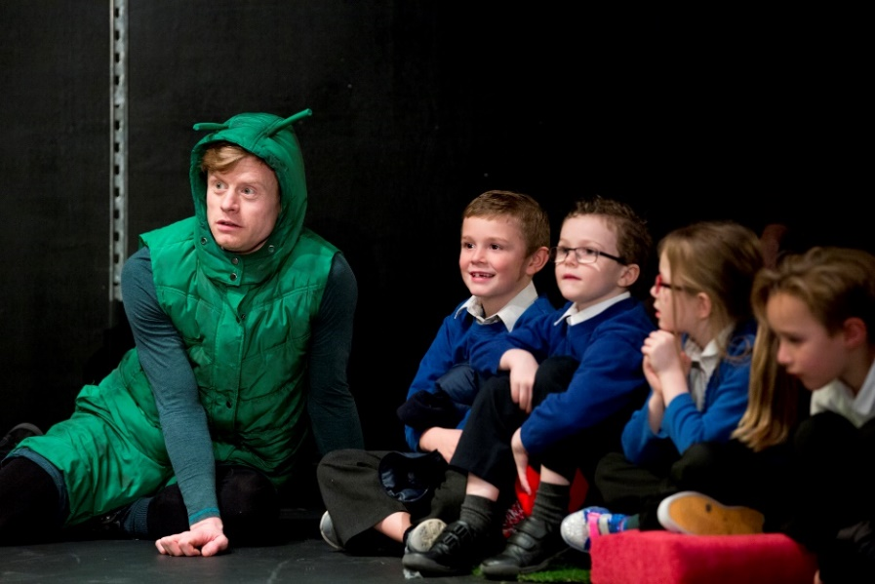

THE HULLABALOO
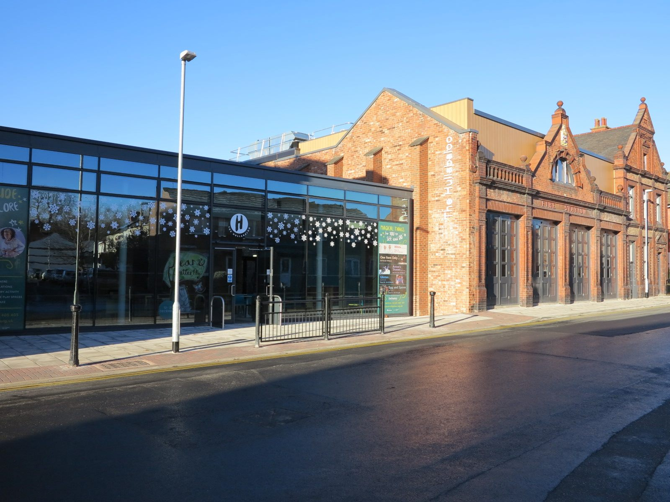

In December 2017, Theatre Hullabaloo realised the dream of opening a purpose-built venue for children and families in Darlington. The Hullabaloo presents a year-round programme of world-class performances, free creative play installations, family-focussed activities, and participatory work with particular emphasis on early years creativity.

‘I feel lucky that we have such an exciting arts facility so close to home as my daughter grows up’

- Audience member

The venue has already welcomed over 55,000 children and their grown-ups through its doors to see wonderful theatre specially made for them, engage in magical play installations and much more. The venue was named ‘Best Family Venue 2019’ in the national Fantastic for Families awards.

OUR VISION

A world where art and creativity for children is as brilliant and inspiring as they are and is a fundamental part of everybody’s childhood

OUR MISSION

Theatre Hullabaloo champions the rights of children to art and creativity as an irreducible part of child development. We do this by making, presenting and advocating an inspiring and ambitious programme of theatre and play which is accessible to all children and families and speaks to all stakeholders in childhood

OUR VALUES
Theatre Hullabaloo is:
BOLD
IMAGINATIVE
We are artistically ambitious for our audiences and take risks in the ideas, stories and forms that we use to make meaning of our world
CHILD CENTRED
We celebrate the power of the imagination to make positive change. Imagination is magical, it stimulates creativity and innovation

Children are at the heart of everything we do
ACCESSIBLE
We are passionate about the rights of all children and families to have the best possible experience of our work, to feel invited and able to participate and to be fully represented in that work
COLLABORATIVE
We believe that we can achieve more when we develop ideas collaboratively, engage with a broad range of voices and make space for everyone to contribute

Our Strategic Aims 2021-23

- To ensure The Hullabaloo is accessible to all, increasing engagement with local communities to ensure The Hullabaloo is meaningful to more children, families and schools locally and regionally.

- To increase the profile of Theatre Hullabaloo locally, regionally and nationally

- To achieve greater organisational sustainability and reduce our environmental impact

- To contribute to the recovery of artists and communities from the Covid-19 pandemic

STRUCTURE & GOVERNANCE
Theatre Hullabaloo is the trading name of Cleveland Independent Theatre Company Ltd and is a registered charity and a company limited by guarantee governed by its charitable objects and Memorandum and Articles of Association. Theatre Hullabaloo currently has a staff team of seven and an array of freelancers that make up the wider creative and project teams.

Theatre Hullabaloo is governed by a board of eleven trustees which meets five times a year to administer the charity. The board also operates a finance sub-group which meets quarterly and other subgroups in areas of staffing, income generation and access and inclusivity.

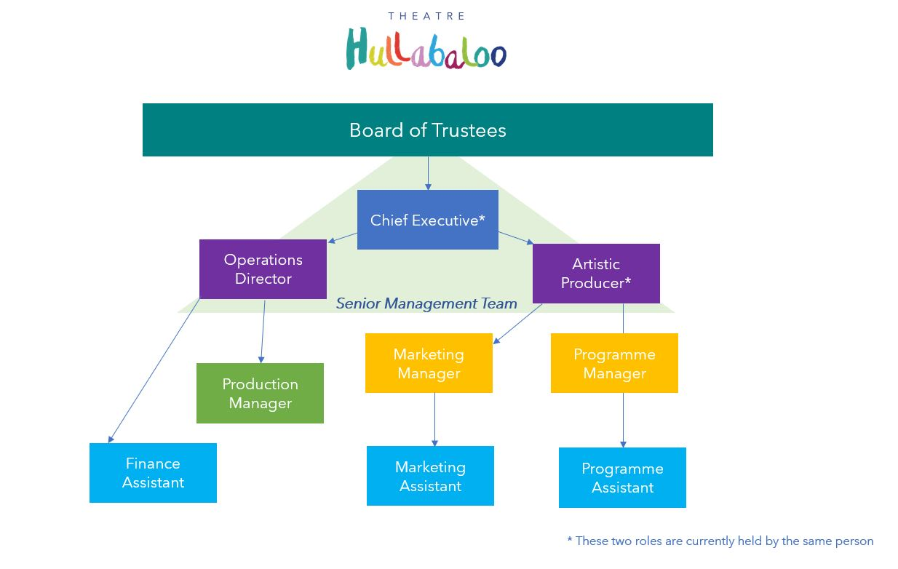

THE ROLE

Title: Programme Assistant
Salary: £19,500 per annum pro rata
Hours: 20 hours per week
Contract type: Part time, permanent (6 month probationary period applies)
Annual leave: 27 days per annum plus bank holidays (pro rata)

We are proud to be a family friendly employer and operate a flexible working policy, in order to help our staff achieve a healthy work/life balance. Theatre Hullabaloo is a Living Wage Employer and is signed up to the Breathe Culture Pledge which is our commitment to the wellbeing of our team.

OVERVIEW

The Programme Assistant supports the development and delivery of the artistic and engagement programmes at The Hullabaloo and across Theatre Hullabaloo’s wider programme.

The role reports to the Programme Manager and works closely alongside the Marketing Assistant to ensure programme and marketing meet Audience Development objectives. The Programme Assistant’s role focuses mainly on work that takes place at The Hullabaloo, implementing and coordinating areas of the visiting companies programme, family events and participation activity, plus some community outreach.

MAIN RESPONSIBILITIES
- Work with the Programme Manager to coordinate an artistic programme of visiting companies, creative play installations and schools’ engagement.
- Coordinate programmes of activity for families and groups of children and young people to ensure the building is animated,
- Coordinate and manage birthday party and private event space hire (coordinating booking, facilitating booking on the day, meeting and greeting)
- Represent the organisation at community events, with a particular emphasis on the programme
- Support the Programme Manager in the recruitment, training and management of Hullabaloo Hosts and volunteers and the scheduling of casual staff
- Act as a Hullabaloo Host to support Front of House or Creative Play in the case of staff absence
- Draft all contracts and letters of agreements for visiting companies, freelance artists and artistic staff connected to residencies.
- Coordinate visiting companies and artists (issuing Deal Sheets, issuing contracts, sending tech packs, liaising with technical staff about specific timings and requirements, sending stage door names, organising leisure passes, meeting and greeting, organising welcome baskets, booking travel & accommodation as required)
- Keep updated room bookings on Artifax and ensure spaces are booked for all programme requirements
- Research and identify artists or programme elements that would enhance the family offer at The Hullabaloo
- Develop craft ideas and source and maintain the resources so that there is a good range of activities available
- Support the coordination of teacher forums, staff programme briefings and other training activities (led by the Programme Manager)
- Coordinate all logistics in relation to visiting companies and artists, ensuring effective communication with technical, marketing, staff teams, partners and Hippodrome operations staff (Programme Manager oversees Hippodrome programme and venue operations).
- Support the booking of tour accommodation and tour scheduling as necessary
- Support other areas of Theatre Hullabaloo’s programme of work as required.
- Undertake all aspects of project administration, including budget monitoring.
- Develop and prepare all materials required for evaluation and monitoring. Ensure there is robust monitoring in place for all projects.
- Contribute to the collection of audience surveys (with the Marketing Assistant)
- Collate data linked to the impact of the programme and be an active contributor to evaluation of projects and reflections on organisational performance
- Work within agreed budgets and ensure that value for money is sought.

General

- Act as an advocate for the company, communicating enthusiastically and confidently about our work.
- Work in line with the company’s mission, vision and values.
- Adhere to Theatre Hullabaloo’s Health and Safety, GDPR and Safeguarding procedures at all times
- Promote equality and inclusion within the workplace
- Offer a high level of customer and audience care at all times
- Be available to work occasional evenings and weekends when required, along with a handful of meetings and company commitments throughout the year.
- General office administrative duties (shared with the Marketing & Finance Assistants) such as telephone answering, responding to emails, recycling, filing etc

Additional

- Theatre Hullabaloo is an equal opportunities employer and we are committed to attracting and recruiting candidates from all communities.
- As a family-friendly organisation, working hours can be flexible.
- Holiday entitlement: 35 days per annum (including public holidays) pro rata.
- No overtime is payable but TOIL may be taken in agreement with your line manager.
PERSON SPECIFICATION
PERSON SPECIFICATION
ESSENTIAL CRITERIA | Application | Interview
Excellent organisational and planning skills | • | •
Genuine passion for cultural activities for families with young children | • | •
Ability to work as part of a team as well as using own initiative | • | •
Ability to prioritise work, to work under pressure and deliver to deadlines |  | •
Ability to manage own workload and work across projects simultaneously | • | •
Previous experience of working within an office environment |  | •
Good time management skills | • | •
Good attention to detail and ability to proofread | • | •
Good communication skills (with line manager, staff team and stakeholders) | • | •
Good IT skills, proficient in Word, Excel and the ability to use new software | • | •
The ability to be resourceful and seek the best value for money |  | •
Have a clear understanding of Theatre Hullabaloo’s values and mission |  | •
DESIRABLE CRITERIA
Experience of working within an administrative role or similar | • | •
Experience of developing participatory projects for families and young audiences | • | •
Knowledge of Theatre Hullabaloo’s work | • | •
Interest in theatre and cultural activities for young audiences | • | •

HOW TO APPLY

Please visit https://airtable.com/shrwES5UULV2u7hHd to complete an application form. You will be asked to upload a Word document application form which can be found on our website alongside this job pack at: https://www.theatrehullabaloo.org.uk/who-are-we/join-the-team/

We want to help applicants to fully represent what they can offer the organisation, so if you feel our application form isn't the best format for you, please contact us at info@theatrehullabaloo.org.uk so that we can give you access to what you need to apply or attend for an interview.

We will be scoring your application based on how well you demonstrate you meet the essential criteria above, so make sure to include all relevant skills and experience so we can shortlist accurately.

Theatre Hullabaloo is an Equal Opportunities Employer and recognises the importance and advantages of diverse workplaces and communities. We particularly welcome applications from those currently underrepresented in our organisation, specifically those who identify as from an alternative background to White, for example People of South, East, West and Central Asian heritage, African and Caribbean heritage, Middle East heritage, Latinx people and mixed heritage, and those who are d/Deaf or disabled.

Please note that CVs will not be accepted, and we cannot accept physical copies of applications as we are not currently working in the building.

Application deadline: 21st June 2021, 12 noon
Interview dates: 1st & 2nd July 2021
If you would like an informal conversation about the role, please contact the office by emailing info@theatrehullabaloo.org.uk.

PRIVACY NOTICE

Theatre Hullabaloo will collect and maintain some personal information about you throughout the recruitment and selection process. The organisation is committed to being transparent about how it collects and uses that data and to meeting its data protection obligations. The full applicant privacy policy is on our website alongside the application pack.

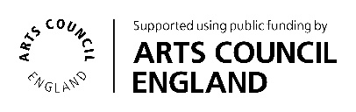
The Hullabaloo, Borough Road,
Darlington DL1 1 SG
01325 405680
info@theatrehullabaloo.org.uk
www.theatrehullabaloo.org.uk

Theatre Hullabaloo is a trading name of Cleveland Independent Theatre Company
Company Registration 01458421 - Registered Charity 279690

