Birthday Party Enquiry Form

- Which date would you like to have your party?

- Which package would you like?

☐Creative Play Package

☐Combined Birthday Package
The show I would like to see is enter the show title on enter the date of the show at enter the start time of the show

- Please provide the following details:

Child’s name: Child’s name

Child’s Gender: Child’s Gender

Their age on their birthday: Their age on their birthday

Date of their birthday: Date of their birthday

- How many children will be attending as party guests (up to a maximum of 15)? Enter the number of children

- How many children are under 6 months old, if any? (These will not be included as party guests). Enter the number of children

- How many adults will be attending? Enter the number of adults

- If choosing the performance package, please indicate how many performance tickets you will need in total? Enter the number of tickets (in total)

- Are there any dietary requirements in your group? Yes or No. If yes, please give more information.

- What is your preferred time for the birthday buffet? (We’d recommend starting the buffet at 3.45pm/4.00pm) Enter the time

- Are you bringing a Birthday Cake? Yes or No
If yes, would you like us to lead on singing Happy Birthday? Yes or No
If yes, would you like us to provide napkins/bags to wrap up slices of cake? Yes or No

Your contact details:

Your name: Please enter your full name

Your address: Please enter your full address

Your email address: Please enter your email address

Your phone number: Please enter your phone number

Is there anything else you’d like to tell us about your enquiry?
Enter any further information here

Thank you

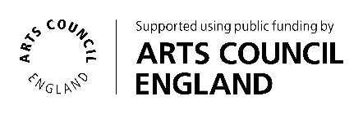
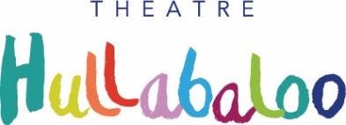
Please return this form to hannahmunro@theatrehullabaloo.org.uk. If you would like to discuss this in more detail, please contact Hannah Munro on 01325 405680

